Haswell, Drew A
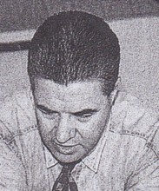
Graduated with BSc Forestry from ANU in 1972. Awarded MSc in 1987. Started work with Forests Department at Pemberton in 1973. Transferred to Collie 1977. In Northern Forests Region in 1980s. Appointed Regional Manager Metropolitan Region in 1987. CALMfire senior fire officer at Como in 2000.

